⋯

⋯

⋯

○

⋯

⋯

⋯

⋯

题

⋯

⋯

⋯

⋯

答

⋯

⋯

⋯

* ⋯
* 要

班

⋯

⋯

⋯

⋯

不

⋯

⋯

⋯

：

名 ⋯

姓 内

⋯

⋯

⋯

⋯

线

⋯

* ⋯

号⋯

* ⋯

考

封

准

⋯

⋯

⋯

⋯

密

⋯

⋯

⋯

⋯

|  |  |  |
| --- | --- | --- |
| ○ | XXXX 中学作文考试专用稿纸 |  |
|  |  |
| ⋯ |  |  |

100

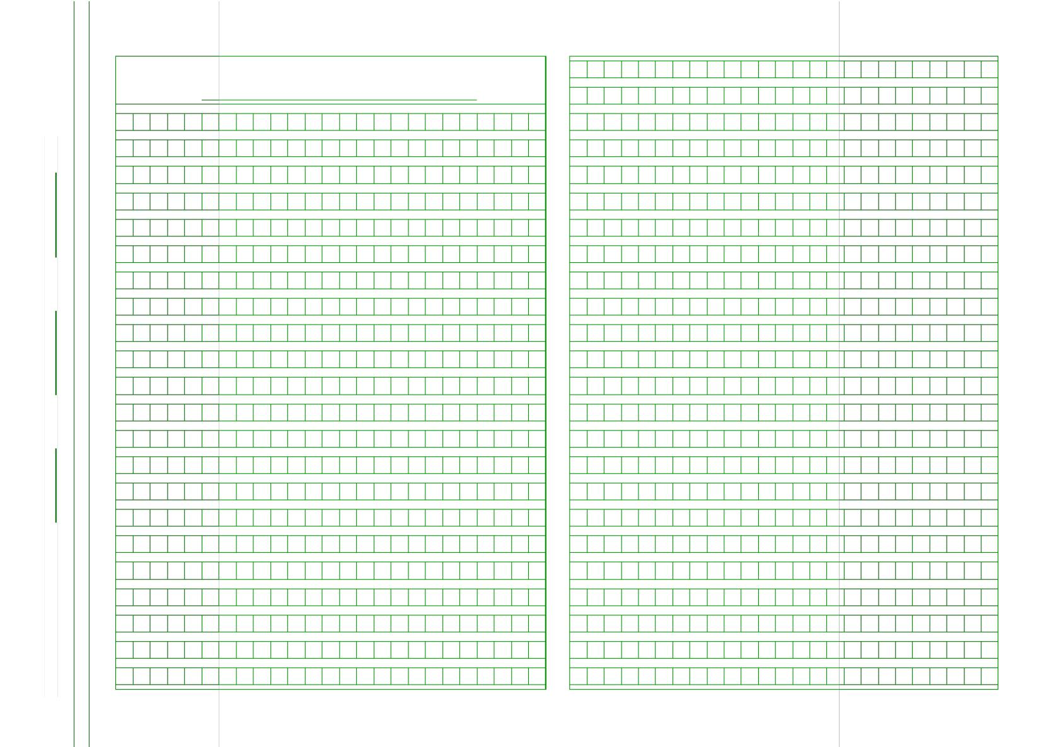

200

30000

400

500

600

700

800

900

1000

1100

* 25× 24 ×2＝1200 ）